**Exploratory Data Analysis- Summary**

Our data consists of 12 columns and 918 rows. There are 7 numeric categories and 5 categorical.

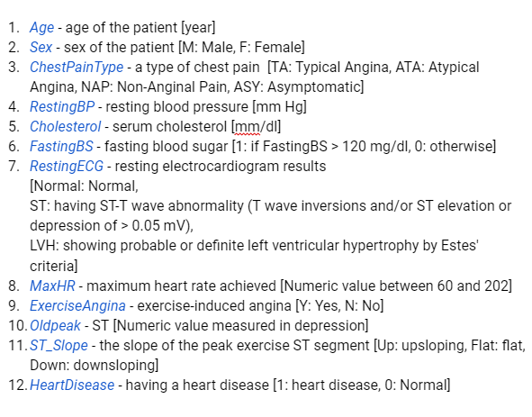

Summary of attributes- taken from our attribute description file

There are no missing values. Statistically, some outliers exist, but it seems these are not incorrect measurements or erroneous inputs, so we see no reason to omit them.

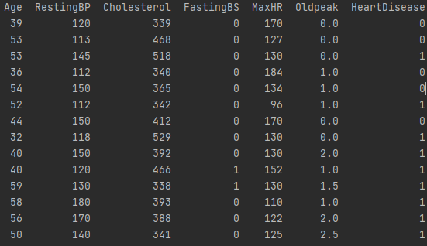

Sample of outliers taken from our DataQualityAssessment.py file

There aren’t many very strong correlations between the variables. Exercise Angina and Oldpeak both have relatively significant correlation between each other and heart disease. The correlations also tell us that more males had heart disease issues then women.

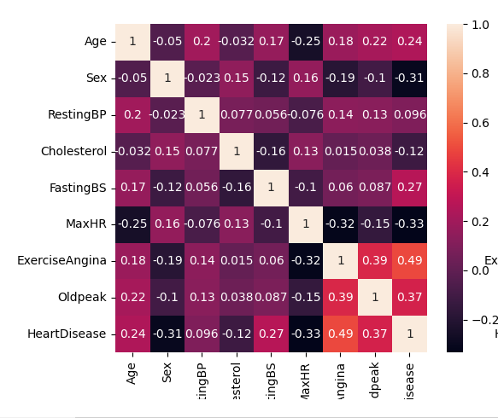

Correlation matrix, created by our correlations.py file